Q. Demonstrate the RIP Routing in Packet Tracer.
Aim : To write a code to demonstrate RIP routing in packet tracer. Steps:
- In packet tracer take 2 PCs and 2 Routers.
- Connect Router0 with PC0 via fastethernet0/0 using cross-copper cord and Router1 with PC1 via fasethernet0/0 using cross-copper cord.
- Connect both router via fastethernet0/1 using cross-copper cord.
- Set the IP address and default gateway of both the PCs in ip configuration of both the PCs respectively.

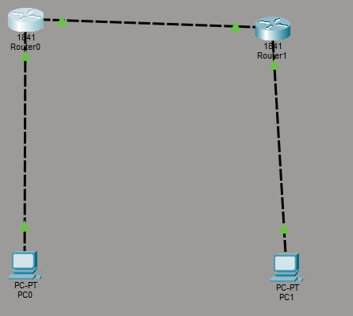
Topology:

Router0:
Router> enable
Router# configure terminal Router(config)# interface fastethernet0/0
Router(config-if)# ip address 192.168.1.1 255.255.255.0

Router(config-if)# no shutdown Router(config-if)# exit

Router(config)# interface gigabitEthernet0/1 Router(config-if)# ip address 10.0.0.1 255.255.255.0 Router(config-if)# no shutdown
Router(config-if)# exit Router(config)# router rip Router(config-router)# version 2
Router(config-router)# network 192.168.1.0
Router(config-router)# network 10.0.0.0 Router(config-router)# no auto-summary Router(config-router)# exit

Router(config)# end Router1:
Router> enable
Router# configure terminal
Router(config)# interface gigabitEthernet0/0 Router(config-if)# ip address 10.0.0.2 255.255.255.0 Router(config-if)# no shutdown
Router(config-if)# exit

Router(config)# interface gigabitEthernet0/1 Router(config-if)# ip address 192.168.2.1 255.255.255.0 Router(config-if)# no shutdown
Router(config-if)# exit Router(config)# router rip Router(config-router)# version 2
Router(config-router)# network 10.0.0.0

Router(config-router)# network 192.168.2.0 Router(config-router)# no auto-summary Router(config-router)# exit

Router(config)# end Router#show ip route Router#show ip protocol Output:
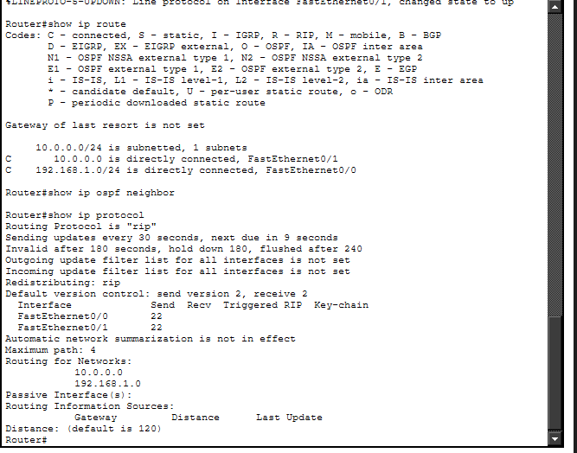
Verification:In PC0 command prompt. C:>ipconfig
C:\>ping 192.168.2.2
Output:

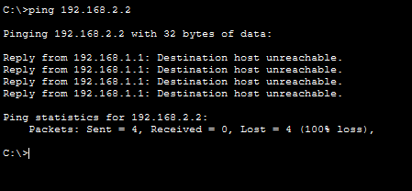
Conclusion:The abovee topology has been executed successfully.

